Topic – 5

Question 1: Search an Element in a Sorted Array

Aim
To search for a key element in a sorted array using the Binary Search (Divide and Conquer) method.

Algorithm
- Read the number of elements n.
- Read the sorted array and the key value.
- Set low = 0 and high = n - 1.
- Repeat while low <= high:
  - Find mid = (low + high) // 2.
  - If array[mid] == key, print its position as mid + 1.
  - If key < array[mid], search the left half.
  - Otherwise, search the right half.
- If the key is not found, print "Element not found".

Code:
n = int(input())
arr = list(map(int, input().split()))
key = int(input())

low = 0
high = n - 1
found = False

while low <= high:
mid = (low + high) // 2

if arr[mid] == key:
print("Element found at position", mid + 1)
found = True
break
elif key < arr[mid]:
high = mid - 1
else:
low = mid + 1

if not found:
print("Element not found")
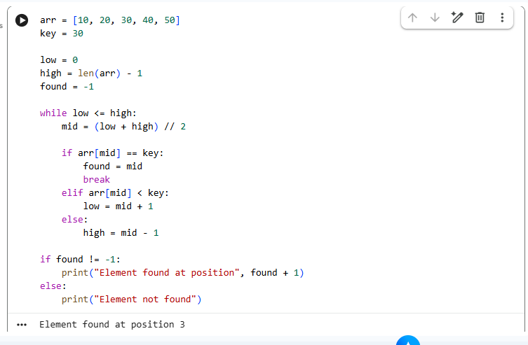

Result
For key 30:
Element found at position 3
For key 25:
Element not found

Question 2: Find the Index of a Given Number

Aim
To find the index of a target number in a sorted array using Binary Search.

Algorithm
- Read n, the sorted array, and the target.
- Set low = 0, high = n - 1.
- Find the middle element.
- Compare the middle element with the target.
- Search the appropriate half until the target is found.
- Print the index, or -1 if not found.

Code:
n = int(input())
arr = list(map(int, input().split()))
target = int(input())

low = 0
high = n - 1
index = -1

while low <= high:
mid = (low + high) // 2

if arr[mid] == target:
index = mid
break
elif target < arr[mid]:
high = mid - 1
else:
low = mid + 1

print("Index =", index)
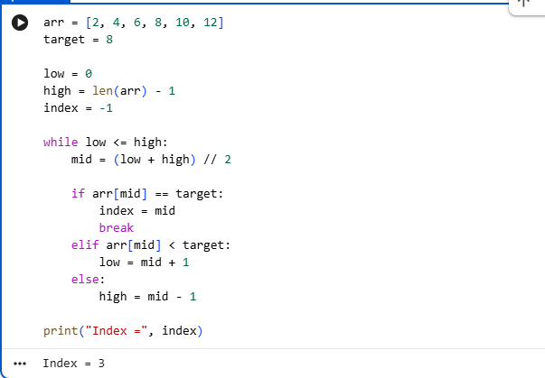

Result
For target 8:
Index = 3
For target 5:
Index = -1

Question 3: Count the Number of Iterations in Binary Search

Aim
To perform Binary Search and count the number of iterations required to find an element.

Algorithm
- Read n, the sorted array, and the key.
- Initialize low, high, and iterations = 0.
- Repeat Binary Search until the element is found or the search range becomes empty.
- Increase the iteration count for every search step.
- Display whether the element is found and the number of iterations.

Code:
n = int(input())
arr = list(map(int, input().split()))
key = int(input())

low = 0
high = n - 1
iterations = 0
found = False

while low <= high:
iterations += 1
mid = (low + high) // 2

if arr[mid] == key:
found = True
break
elif key < arr[mid]:
high = mid - 1
else:
low = mid + 1

if found:
print("Element found")
else:
print("Element not found")

print("Iterations =", iterations)

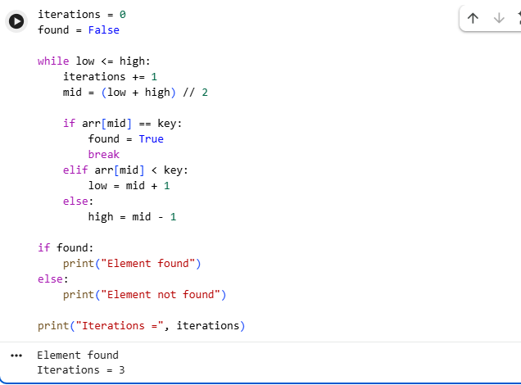

Result
For key 25:
Element found
Iterations = 2
For key 40:
Element not found
Iterations = 3

Question 4: Find the First Occurrence of an Element

Aim
To find the first occurrence of a key in a sorted array containing duplicate elements using Binary Search.

Algorithm
- Read the array and key.
- Perform Binary Search.
- When the key is found, store its index.
- Continue searching in the left half to find an earlier occurrence.
- Print the first occurrence.

Code
n = int(input())
arr = list(map(int, input().split()))
key = int(input())

low = 0
high = n - 1
result = -1

while low <= high:
mid = (low + high) // 2

if arr[mid] == key:
result = mid
high = mid - 1
elif key < arr[mid]:
high = mid - 1
else:
low = mid + 1

if result != -1:
print("First occurrence at index", result)
else:
print("Element not found")

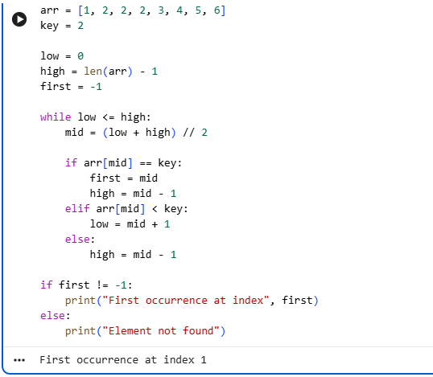

Result
For key 2:
First occurrence at index 1
For key 7:
Element not found

Question 5: Find the Last Occurrence of an Element

Aim
To find the last occurrence of a key in a sorted array containing duplicate elements using Binary Search.

Algorithm
- Read the array and key.
- Perform Binary Search.
- When the key is found, store its index.
- Continue searching in the right half.
- Print the last occurrence.

Code
n = int(input())
arr = list(map(int, input().split()))
key = int(input())

low = 0
high = n - 1
result = -1

while low <= high:
mid = (low + high) // 2

if arr[mid] == key:
result = mid
low = mid + 1
elif key < arr[mid]:
high = mid - 1
else:
low = mid + 1

if result != -1:
print("Last occurrence at index", result)
else:
print("Element not found")

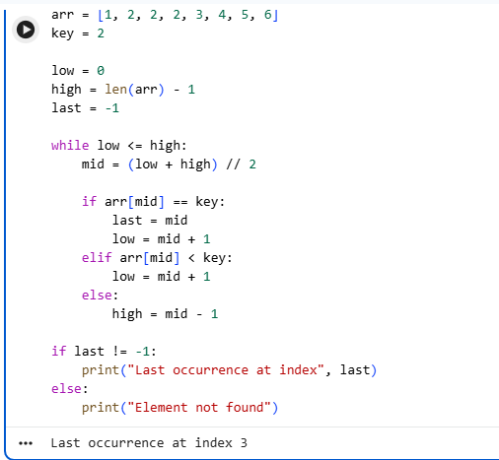

Result
For key 2:
Last occurrence at index 3
For key 9:
Element not found

Question 6: Highest and Lowest Temperature Recorded

Aim
To find the minimum and maximum temperatures using the Divide and Conquer approach.

Algorithm
- Divide the array into smaller halves recursively.
- If one element remains, it is both minimum and maximum.
- Find minimum and maximum values in the left half.
- Find minimum and maximum values in the right half.
- Compare the results and return the overall minimum and maximum.
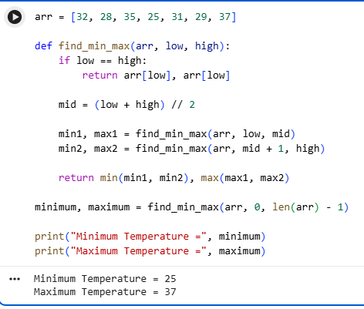

Code
def find_min_max(arr, low, high):
if low == high:
return arr[low], arr[low]

mid = (low + high) // 2

min1, max1 = find_min_max(arr, low, mid)
min2, max2 = find_min_max(arr, mid + 1, high)

minimum = min(min1, min2)
maximum = max(max1, max2)

return minimum, maximum

n = int(input())
arr = list(map(int, input().split()))

minimum, maximum = find_min_max(arr, 0, n - 1)

print("Minimum Temperature =", minimum)
print("Maximum Temperature =", maximum)

Result
Minimum Temperature = 25
Maximum Temperature = 37

Question 7: Best and Worst Student Marks

Aim
To find the minimum and maximum student marks using the Divide and Conquer approach.

Algorithm
- Divide the marks array into two halves.
- Recursively find minimum and maximum in each half.
- Compare the results from both halves.
- Print the minimum and maximum marks.

Code
def find_min_max(arr, low, high):
if low == high:
return arr[low], arr[low]

mid = (low + high) // 2

min1, max1 = find_min_max(arr, low, mid)
min2, max2 = find_min_max(arr, mid + 1, high)

return min(min1, min2), max(max1, max2)

n = int(input())
arr = list(map(int, input().split()))

minimum, maximum = find_min_max(arr, 0, n - 1)

print("Minimum Mark =", minimum)
print("Maximum Mark =", maximum)
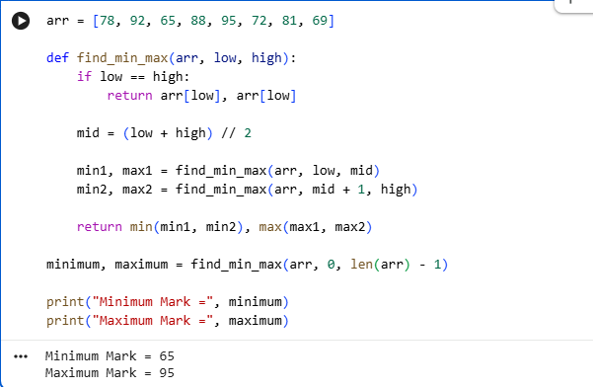

Result
Minimum Mark = 65
Maximum Mark = 95

Question 8: Stock Price Analysis

Aim
To determine the minimum and maximum stock prices using Divide and Conquer.

Algorithm
- Divide the stock price array into two halves.
- Recursively calculate minimum and maximum for each half.
- Combine the results.
- Display the minimum and maximum stock prices.

Code
def find_min_max(arr, low, high):
if low == high:
return arr[low], arr[low]

mid = (low + high) // 2

min1, max1 = find_min_max(arr, low, mid)
min2, max2 = find_min_max(arr, mid + 1, high)

return min(min1, min2), max(max1, max2)

n = int(input())
arr = list(map(int, input().split()))

minimum, maximum = find_min_max(arr, 0, n - 1)

print("Minimum Stock Price =", minimum)
print("Maximum Stock Price =", maximum)
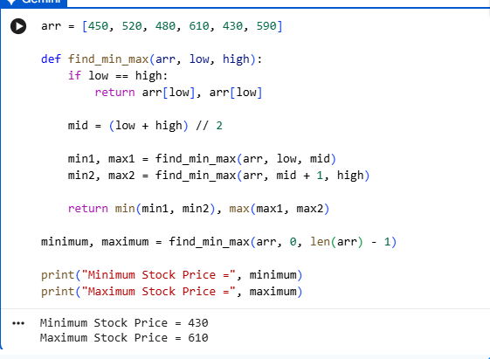

Result
Minimum Stock Price = 430
Maximum Stock Price = 610

Question 9: Fastest and Slowest Race Times

Aim
To find the fastest and slowest race completion times using Divide and Conquer.

Algorithm
- Divide the race times into two halves.
- Find the minimum and maximum in each half recursively.
- Compare both halves.
- The minimum value is the fastest time.
- The maximum value is the slowest time.

Code
def find_min_max(arr, low, high):
if low == high:
return arr[low], arr[low]

mid = (low + high) // 2

min1, max1 = find_min_max(arr, low, mid)
min2, max2 = find_min_max(arr, mid + 1, high)

return min(min1, min2), max(max1, max2)

n = int(input())
arr = list(map(int, input().split()))

fastest, slowest = find_min_max(arr, 0, n - 1)

print("Fastest Time =", fastest)
print("Slowest Time =", slowest)

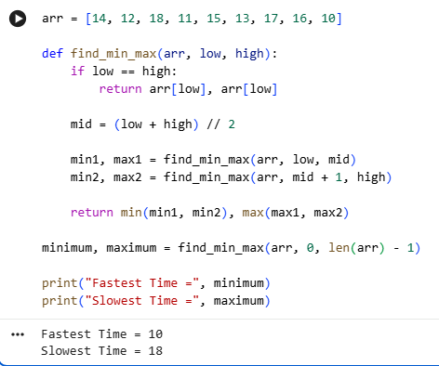

Result
Fastest Time = 10
Slowest Time = 18

Question 10: Largest and Smallest Building Heights

Aim
To find the minimum and maximum building heights using the Divide and Conquer approach.

Algorithm
- Divide the building height array into two halves.
- Find the minimum and maximum of each half recursively.
- Combine the results by comparing minimum and maximum values.
- Display the shortest and tallest building heights.

Code
def find_min_max(arr, low, high):
if low == high:
return arr[low], arr[low]

mid = (low + high) // 2

min1, max1 = find_min_max(arr, low, mid)
min2, max2 = find_min_max(arr, mid + 1, high)

return min(min1, min2), max(max1, max2)

n = int(input())
arr = list(map(int, input().split()))

minimum, maximum = find_min_max(arr, 0, n - 1)

print("Minimum Height =", minimum)
print("Maximum Height =", maximum)

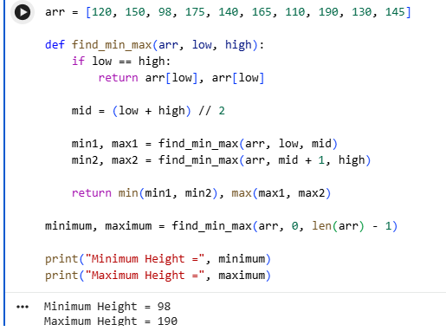

Result
Minimum Height = 98
Maximum Height = 190

